23I-0544

MUHAMMAD HAMMAD

BCS-3D

LAB 05:

TASKS:

TASK 01:

INCLUDE Irvine32.inc

.data

val1 DWORD 8000

.code

main PROC

mov eax, 0

mov ebx, 1

mov eax, val1

add eax, ebx

call DUMPREGS

call crlf

exit

main endp

end main

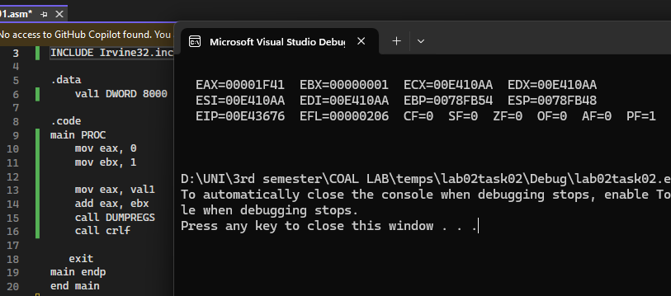

TASK 03:

INCLUDE Irvine32.inc

.data

arrayB BYTE 61, 43, 11, 52, 25

arrayT BYTE 5 DUP(?)

.code

main PROC

mov al, byte ptr arrayB+2

mov byte ptr arrayT, al

mov al, byte ptr arrayB+4

mov byte ptr arrayT+1, al

mov al, byte ptr arrayB+1

mov byte ptr arrayT+2, al

mov al, byte ptr arrayB+3

mov byte ptr arrayT+3, al

mov al, byte ptr arrayB

mov byte ptr arrayT+4, al

movzx eax, byte ptr arrayT

call WriteInt

call Crlf

movzx eax, byte ptr arrayT+1

call WriteInt

call Crlf

movzx eax, byte ptr arrayT+2

call WriteInt

call Crlf

movzx eax, byte ptr arrayT+3

call WriteInt

call Crlf

movzx eax, byte ptr arrayT+4

call WriteInt

call Crlf

exit

main ENDP

END main

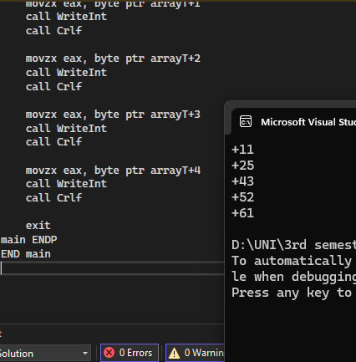

TASK 04:

INCLUDE Irvine32.inc

.data

arrayB BYTE 10, 20, 30

arrayW WORD 150, 250, 350

arrayD DWORD 600, 1200, 1800;

SUM1 DWORD 0

SUM2 DWORD 0

SUM3 DWORD 0

.code

main PROC

movzx ebx, byte ptr arrayB

add SUM1, ebx

movzx ebx, word ptr arrayW

add SUM1, ebx

mov ebx, arrayD

add SUM1, ebx

mov eax, DWORD PTR SUM1

call writeint

call crlf

movzx ebx, byte ptr arrayB+1

add SUM2, ebx

movzx ebx, word ptr arrayW+2

mov ebx, arrayD+4

add SUM2, ebx

mov eax, DWORD PTR SUM2

call writeint

call crlf

movzx ebx, byte ptr arrayB+2

add SUM3, ebx

movzx ebx, word ptr arrayW+4

add SUM3, ebx

mov ebx, arrayD+8

add SUM3, ebx

mov eax, DWORD PTR SUM3

call writeint

call crlf

exit

main endp

end main

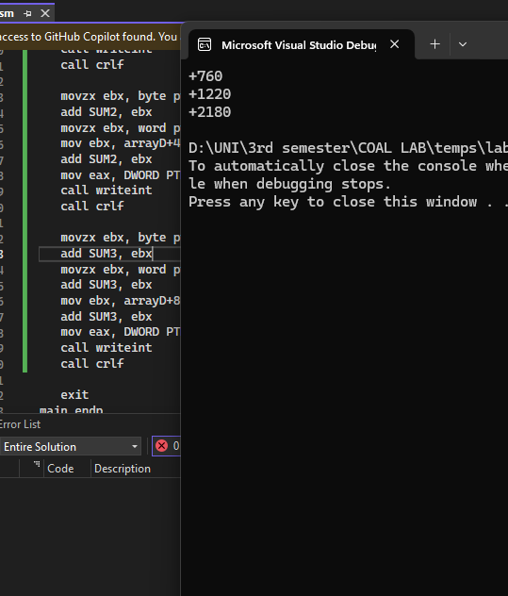

TASK 05:  
INCLUDE Irvine32.inc

.data

arrayB BYTE 10, 20 ,30, 40

arrayT BYTE 4 DUP(?)

.code

main PROC

mov al, arrayB+3

mov arrayT, al

movzx eax, arrayT

call writeint

call crlf

mov al, arrayB+2

mov arrayT+1, al

movzx eax, arrayT+1

call writeint

call crlf

mov al, arrayB+1

mov arrayT+2, al

movzx eax, arrayT+2

call writeint

call crlf

mov al, arrayB

mov arrayT+3, al

movzx eax, arrayT+3

call writeint

call crlf

exit

main ENDP

END main

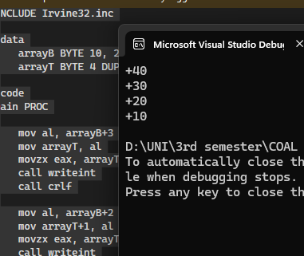

TASK 06:

INCLUDE Irvine32.inc

.data

dwordVal DWORD 50, 11, 12, 13

result DWORD 0

.code

main PROC

mov eax, 0

mov esi, OFFSET dwordVal

mov eax, [esi]

add esi, 4

mov ebx, [esi]

sub eax, ebx

add esi, 4

mov ebx, [esi]

sub eax, ebx

add esi, 4

mov ebx, [esi]

sub eax, ebx

add esi, 4

mov result, eax

call WriteInt

exit

main ENDP

END main

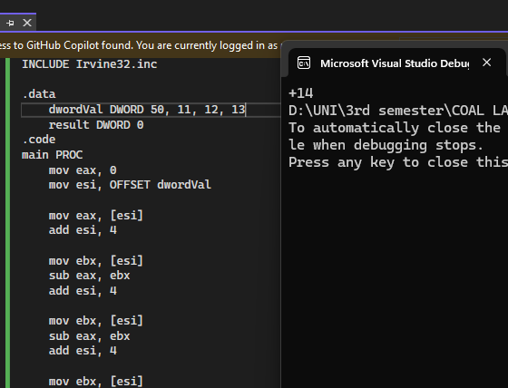

TASK 07:  
INCLUDE Irvine32.inc

.data

arrayB BYTE 60, 70, 80

arrayW WORD 150, 250, 350

arrayD DWORD 600, 1200, 1800

SUM1 DWORD 0

SUM2 DWORD 0

SUM3 DWORD 0

.code

main PROC

mov esi, OFFSET arrayB

movzx eax, BYTE PTR [esi]

movzx ebx, BYTE PTR [esi + 1]

add eax, ebx

mov SUM1, eax

call WriteInt

call crlf

mov esi, OFFSET arrayW

movzx eax, WORD PTR [esi]

movzx ebx, WORD PTR [esi + 2]

add eax, ebx

mov SUM2, eax

call WriteInt

call crlf

mov esi, OFFSET arrayD

mov eax, [esi]

mov ebx, [esi + 4]

add eax, ebx

mov SUM3, eax

call WriteInt

call crlf

exit

main ENDP

END main

